**image.h**

#ifndef IMAGE_H

#define IMAGE_H

typedef struct

{ // Total: 54 bytes

uint16_t type; // Magic identifier: 0x4d42

uint32_t size; // File size in bytes

uint16_t reserved1; // Not used

uint16_t reserved2; // Not used

uint32_t offset; // Offset to image data in bytes from beginning of file (54 bytes)

uint32_t dib_header_size; // DIB Header size in bytes (40 bytes)

int32_t width_px; // Width of the image

int32_t height_px; // Height of image

uint16_t num_planes; // Number of color planes

uint16_t bits_per_pixel; // Bits per pixel

uint32_t compression; // Compression type

uint32_t image_size_bytes; // Image size in bytes

int32_t x_resolution_ppm; // Pixels per meter

int32_t y_resolution_ppm; // Pixels per meter

uint32_t num_colors; // Number of colors

uint32_t important_colors; // Important colors

} BMPHeader;

typedef struct

{

BMPHeader header;

unsigned char header;

int height;

int width;

int bitDepth;

unsigned char colorTable;

unsigned char buffer;

};

int imageReader(const char *, int *, int *, int *, unsigned char *, unsigned char *, unsigned char *);

int imageWriter(const char *, unsigned char *, unsigned char *, unsigned char *, int);

int initialize(const char *, const char *);

#endif

**image.c**

// define bmp header size , colorTable and custom image size as per the structure of bmp file.

#define BMP_HEADER_SIZE 54

#define BMP_COLOR_TABLE_SIZE 1024

#define CUSTOM_IMG_SIZE 1024 * 1024

int imageReader(const char *imgName, int *_height, int *_width, int *_bitDepth, unsigned char *_header, unsigned char *_colorTable, unsigned char *_buffer);

int imageWriter(const char *imgName, unsigned char *header, unsigned char *colorTable, unsigned char *buffer, int bitDepth);

int initialize(const char *read_image, const char *write_image);

int initialize(const char *read_image, const char *write_image)

{

// Initialize datatypes of header, height, width, BitDepth to use it after reading.

int imgWidth, imgHeight, imgBitDepth;

unsigned char imgHeader[BMP_HEADER_SIZE];

unsigned char imgColorTable[BMP_COLOR_TABLE_SIZE];

unsigned char imgBuffer[CUSTOM_IMG_SIZE];

// Call the read and write function

int checkReader = imageReader(read_image, &imgWidth, &imgHeight, &imgBitDepth, &imgHeader[0], &imgColorTable[0], &imgBuffer[0]);

if (checkReader == 0)

{

printf("Read Successful");

}

else

{

printf("Read Unsuccessful");

}

int checkWriter = imageWriter(write_image, imgHeader, imgColorTable, imgBuffer, imgBitDepth);

if (checkWriter == 0)

{

printf("\nWrite Successful");

}

else

{

printf("\nWrite Unsuccessful");

}

return 0;

}

int imageReader(const char *imgName, int *_height, int *_width, int *_bitDepth, unsigned char *_header, unsigned char *_colorTable, unsigned char *_buffer)

{

int i;

// Initialize a FILE pointer for reading

FILE *streamIn;

// Open the file to read

streamIn = fopen(imgName, "rb");

// Check if the FILE pointer is able to access

if (streamIn == (FILE *)0)

{

printf("Unable to read file\n");

}

for (i = 0; i < 54; i++)

{

// Read the header.

_header[i] = getc(streamIn);

}

// Read the width, height, bitDepth from header.

*_width = *(int *)&_header[18];

*_height = *(int *)&_header[22];

*_bitDepth = *(int *)&_header[28];

// Check if the bitDepth is less than 8 and if it is read the colortable from streamIn.

if (*_bitDepth <= 8)

{

// Read the colortable of size unsigned char from streamIn. 1024 being the

// no of elements of size mentioned before.

fread(_colorTable, sizeof(unsigned char), 1024, streamIn);

}

else

{

printf("BitDepth is greater than 8, can't read the file");

return 1;

}

// Read the data (buffer) from the streamIn.

fread(_buffer, sizeof(unsigned char), CUSTOM_IMG_SIZE, streamIn);

// Close the FILE pointer.

fclose(streamIn);

return 0;

}

int imageWriter(const char *imgName,

unsigned char *header,

unsigned char *colorTable,

unsigned char *buffer,

int bitDepth)

{

// Open the file for write.

FILE *FO = fopen(imgName, "wb");

// Write the header of size 54 bytes

fwrite(header, sizeof(unsigned char), 54, FO);

// Check to see if the bitDepth is less than 8.

if (bitDepth <= 8)

{

// Write the colortable of size unsigned char from streamIn. 1024 being the

// no of elements of size mentioned before.

fwrite(colorTable, sizeof(unsigned char), 1024, FO);

}

else

{

printf("BitDepth is greater than 8, can't write the file");

return 1;

}

// Write the data.

fwrite(buffer, sizeof(unsigned char), CUSTOM_IMG_SIZE, FO);

// Close the write file pointer.

fclose(FO);

return 0;

}

Main function

**main.c**

#include <stdio.h>

#include <stdlib.h>

#include "image.h"

int main()

{

// call initialize function and give the arguments of bmp file to read and write.

initialize("image.bmp", "image_copy.bmp");

}

image.bmp

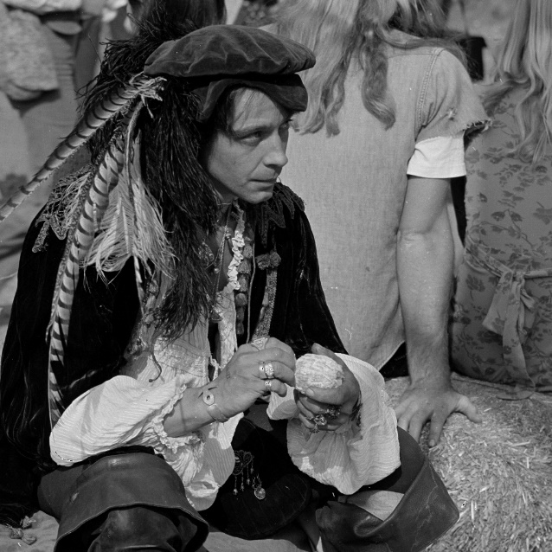

image_copy.bmp

